UPPER DUBLIN CHRISTIAN NURSERY SCHOOL
411 Susquehanna Road
Ambler, PA 19002
215-646-7812
EMAIL: Kvega@udlc.org

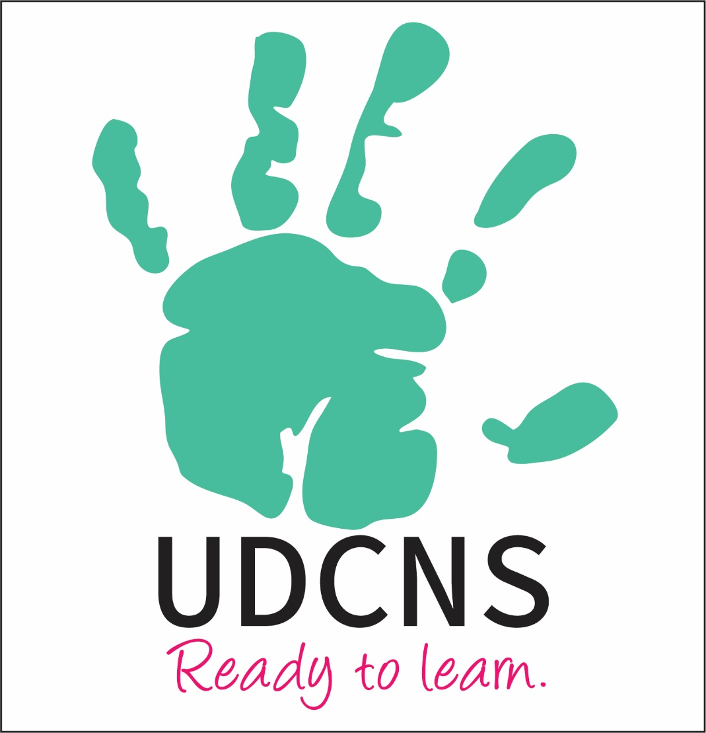

FAMILY HANDBOOK

2022-2023

UPPER DUBLIN CHRISTIAN NURSERY SCHOOL
411 Susquehanna Road, Ambler, PA 19002
215-646-7812
EMAIL: kvega@udlc.org
.
- MISSION AND PHILOSOPHY
- NON DISCRIMINATION POLICY
- SCHOOL HOURS
- TUITION/PAYMENT
- LUNCH BUNCH OPTIONS
- SECURITY AND KEY FOBS
- ARRIVAL AND DISMISSAL
- RELEASE OF CHILDREN
- PARKING LOT SAFETY
- EMERGENCY SCHOOL CLOSING
- FOOD POLICY
- ALLERGIES
- MEDICATIONS
- MEDICAL RECORDS
- ILLNESS
- WHAT TO BRING TO
- CLOTHING
- WORSHIP
- DISCIPLINE
- COMMUNICATION POLICY
- COVID PROTOCOL

UDCNS Family Handbook 2022/2023

The mission of Upper Dublin Christian Nursery School is to help children experience the joy in knowing Jesus, in learning and in sharing God’s love.

SCHOOL PHILOSOPHY
Upper Dublin Christian Nursery School provides an environment where each child is nurtured emotionally and educationally while experiencing the gift of God’s unconditional love and grace. Through play and exploration, our children will learn and prepare for future learning experiences.

NON DISCRIMINATION POLICY
Upper Dublin Christian Nursery School welcomes students of any race, color, national and ethnic origin to all the rights, privileges, programs, and activities generally accorded or made available to students at the school. It does not discriminate on the basis of race, color, national and ethnic origin in administration of its educational policies, admissions policies, scholarship program, and athletic and other school-administered programs.
A diverse environment enriches the learning experience for children by providing exposure to unique cultures and backgrounds. A parent/guardian, who believes they have been discriminated against, may file a complaint of discrimination with any of the following:
Department of Public Welfare Bureau of Equal Opportunity
Room 223, Health and Welfare Bldg.
PO Box 2675
Harrisburg, PA 17105
U S Dept of Health and Human Services Office for Civil Rights
Suite 372, Public Ledger Bldg.
150 South Independence Mall West
Philadelphia, PA 19106-9111

SCHOOL HOURS
Morning classes 9:00 a.m. – 12:00 p.m.
Two Year old Classes 9:15 am – 12:15 p.m.
Lunch Bunch 12:00 p.m. – 2:30 p.m. Monday -Friday
Pre-K (Wonder Bunch) 12:00 p.m. – 2:30 p.m. Tuesday, Wednesday and Thursday
If you need to contact the school during school operating hours, please call 215-646-7812. If you are calling with an emergency, please call the church office at 215-646-7999. If your call is not an emergency, please leave us a message.

TUITION
Tuition is an annual amount collected over is 10 months. Tuition is due the first of each month. Payments are being accepted on line this year. Tuition statements can be provided monthly or quarterly as requested. Late Payments. If payment is not made for the current month, and arrangements have not been made in the nursery school office, a meeting will be scheduled with the director and a pastor to address the late payment. Scholarship money is available for families in need of assistance. Please contact the Director.

PAYMENT
All payments must be made through Breeze, our online payment program. If we are forced to close for covid exposure for more than two consecutive weeks in one calendar month, tuition will be prorated. When using the Breeze management system, if possible, please opt to cover the processing fees when paying. The fees really add up quickly and put a strain on our already very tight budget.

Lunch Bunch is offered Monday through Friday 12:00 p.m. to 2:30pm. The cost is $25 a day.
The two year- old students will have an option to stay from 12pm to 1pm for $10 an hour.
Registration and Payments can be made through the Breeze System. There is a category for Lunch Bunch payments.
WE STRIVE TO BE A PEANUT/TREENUT-FREE SCHOOL! Please no peanut butter or Nutella. Check granola bars carefully. We are happy to warm up food for your child, such as mac and cheese, hotdogs, chicken nuggets, leftovers, etc. Please pack only items requiring 1 to 2 minutes in microwave.

BUCKETS
Buckets are distributed the first day of school for transporting “stuff” to and from school. Please help your child remember to take it home each day and to bring it back each school morning.

WHAT TO BRING TO SCHOOL:
- A seasonal change of clothes, in a zippered plastic bag.
- Children who are not toilet trained must also provide a changing mat, diapers and wipes to be kept in the classroom
- The teachers may request additional items.

Please label EVERYTHING with your child’s name.

ARRIVAL AND DISMISSAL-CAR LINE ONLY
The Pre-K will drop off and pick up on the church side of the parking lot at 9:00 am and 12noon.
The Three Year old students will have drop off and pick up at the main entrance at 9am and 12noon.
The Two Year old students will have drop off and pick up at the main entrance at 9:15am and 12:15pm
All lunch bunch students will have drop off and pick up at the main entrance at 1pm or 2:30pm
Please remember that this drop off time is very busy and our teachers make a great effort to welcome each child every day. They are not available for any conferencing at this time.

PARKING LOT SAFETY
As can be expected, the parking lot is crowded during drop off and pick up. Please use extreme caution!
PLEASE be respectful of the Church’s property. Children should not be permitted to climb trees or run on the flower plant beds.
SECURITY
The front entrance to the nursery school is always locked. All visitors must be buzzed in for access to our building. The Church Staff unlocks the door and greets visitors throughout the day.

RELEASE OF CHILDREN
Parents/guardians will complete a Release Authorization form. Only persons listed on the form will have children released to them. At the beginning of the year (and as necessary) teachers may ask to see a photo identification. This is to ensure that your child is released only to people that you have authorized. Please make any person who might be picking up your child aware of the photo ID requirement. Any changes to the form will require you to complete a new form.

EMERGENCY SCHOOL CLOSING
There are several places to access school-closing information:
- Teachers will text or email parents by 8 am if the school is closed.
- If Upper Dublin School District is closed for inclement weather, UDCNS is closed.
- If Upper Dublin School District is virtual for inclement weather UDCNS is closed.
- FACEBOOK: https://www.facebook.com/UDchristiannurseryschool. Like us and check for updates.

FOOD POLICY
UDCNS will provide snack and water each day.

ALLERGIES
We strive to be peanut/tree nut free at UDCNS. No peanut butter or Nutella should be packed for lunch bunch or Wonder Bunch. Parents must alert teachers of any known allergies for their child, and fill out an allergy action plan (see Director). Any child with a food allergy requiring Benadryl or an Epi-pen must have an Allergy Action Plan completed to attend school. The Epi-Pen and medication must be in the original prescribed box by a physician. It is the Parent’s responsibility to know when their child’s Epi-Pen or medication expires. They must provide a new one once the Epi-Pen or medication expires.
MEDICATIONS
No medication will be administered at school unless a written order from the physician is on file at school. The medication must be in the original container with instructions for administering it on the label. See “ALLERGIES” for children with known food allergies.
MEDICAL RECORDS
Each child is required to have a health form and an emergency form on file in the Nursery School Office. Please be sure that all immunizations are up to date. Please inform your child’s teacher in writing whenever information contained on either form changes. The emergency form, as well as the Release Authorization, must be submitted on the first day of school.
ILLNESS See Covid Protocol page

Every effort is made to keep the children healthy. Please do not send a sick child to school! We are sympathetic to issues of child care; however, for the safety and well-being of all the children, we cannot allow a child who is sick to attend school.
Please do not bring your child to school if he/she has any of the following:
- If your child has a fever please do not bring them to school until he is fever-free for 24 hours WITHOUT having taken a fever–reducer (ibuprophen, acetometiphen or other).
- Diarrhea or vomiting
- Any undiagnosed rash on cheeks, arms, legs, chest or back
- Complaints of a sore or irritated throat

If your child becomes sick with a contagious illness, please notify the school as soon as possible so that we can alert other parents. If your child becomes sick at school, we will always try to reach a parent first. If a parent is unavailable, we will notify your emergency contact. Please list a local person as that contact.
Please read and sign the COVID-19 protocol page. Full COVID protocols are at the bottom of the handbook.

CLOTHING
We hope that your child will want to look nice for school, but PLEASE do not have them wear their best clothes to school. Our curriculum is based on exploration through play – sand, water, mud, paint, cooking, clay, etc. We expect to be MESSY, and we are! During the winter please make sure that your child has a hat, gloves and boots. We still will be going outside. NO SANDALS OR FLIP FLOPS!

WORSHIP
Each class will attend chapel weekly. This will be a special time as we sing songs, hear messages from the Bible, and grow in our love for God and each other.

Positive Behavior Interventional Support/Discipline
Discipline is handled with love and respect for the child. Gentle reminders and in some cases separation from the group may be implemented. Behaviors that do not respond to these methods will be discussed with the parent, the teacher and /or the Director. A pastor is also available to discuss these concerns.

MEDIA POLICY
Throughout the year, school and church staff may be taking pictures of the children at school events in the Church or during classroom activities. These pictures may appear on the Nursery School website, Facebook page, brochures and general marketing materials. No identification of the child will be provided. Please indicate on the Media Policy Permission Section on the emergency contact form your preference regarding your child’s participation in our marketing materials. Upper Dublin Lutheran Church upholds a Social Media Policy that governs staff and volunteers. If you would like to see a copy of this policy, please see the Director.

COMMUNICATION
Communication is essential for you and your child to enjoy all the opportunities and happenings at UDCNS! How can you do this?

- Stay informed by confirming/providing your classroom teacher with current email address. Teachers will often email parents with weekly newsletters.
- Like us on Facebook! https://www.facebook.com/UDchristiannurseryschool
- Check email regularly for emails from the Director.
- Weekly emails are sent home with upcoming events and important dates.

Covid Protocols and Procedures Page
2022/2023
UDCNS follows the CDC and Montgomery County Board of Health COVID Regulations. Masking Indoors is OPTIONAL at this time.
UDCNS follows the CDC and Montgomery County Board of Health for masking requirements. We are mask optional at this time, this may change as COVID numbers in the community spike. We will keep all families informed of any changes that may affect our mask or quarantine/isolation policy.

When may your child return to school after illness:
- Your child may return to school If he/she has been evaluated by a doctor with a note stating they can safely return to school.
- OR For students not evaluated by a doctor, students can only return if ALL of the following has occurred: 1. At least 1 day (24 hours) fever free without the use of fever-reducing medications; AND 2. Improvement in respiratory symptoms (e.g., cough, shortness of breath); AND 3. At least 10 days have passed since symptoms first appeared.
- For a student with another diagnosis for symptom-based school exclusion (i.e. allergies), health care provider clearance is required and should include clinical evaluation but does not require SARS-CoV-2 testing.

Hygiene Measures and Procedures
Admittance:
- If a child is at high-risk for contracting a severe illness such as COVID-19, it is recommended that they not enroll in preschool. (This is a CDC recommendation.)
- Daily home health check: Each day parents should check their child’s temperature and general health before sending them to school. If a child shows symptoms of illness, keep him/her home. A daily health monitoring checklist is provided.
- Handwashing: Children will wash or sanitize their hands when they come into the building, after using the bathroom, and as needed throughout the day. Hands will be washed with soap and water for at least 20 seconds. Hand sanitizer will be used when soap and water is not available.
- Sanitizing/Disinfecting: All hard surfaces will be wiped down throughout the day, before and after use as well as at the end of each day. All surfaces and toys will be sprayed at the end of the session and as necessary. A CDC approved disinfectant solution will be used daily to sanitize the room, surfaces, and toys.
- Social distancing: While physical distancing is recommended, when possible, there will be times when children are playing with each other and with classroom toys. Physical distancing will not always be possible.

Illness Procedure:
- If it is suspected that a child has become ill during the morning (excessive coughing/sneezing or trouble breathing), the child will be moved to another room, the child’s temperature will be taken, and the parent will be called.
If any illness is suspected the parent will be asked to pick-up the child.
- Children and staff who are ill with anything other than COVID19 must have a signed doctor’s note to return to school/work.
- In the event that a child or staff member is found to have contracted the COVID 19 virus, the following will take place:
1. All families and staff will be notified.
2. The child or staff member will be quarantined for a minimum of 5 days and may only
return to school with a doctor’s signed permission and/or negative covid test.
3. Procedures will be reviewed and refined if necessary.

Isolation and Quarantine Protocols For COVID 19:
If You Test Positive for COVID-19 (Isolate)
Everyone, regardless of vaccination status.
- Stay home for 5 days.
- If you have no symptoms or your symptoms are resolving after 5 days, you can leave your house.
- Continue to wear a mask around others for 5 additional days.
- If you have a fever, continue to stay home until your fever resolves.
- A negative covid test is required to return to school if 5 day quarantine is followed.
- If you do not want to or are unable to get your child a COVID test, the 10 day quarantine must be followed. Your child must remain home for 10 days from the date of the positive covid test result.

If You Were Exposed to Someone with COVID-19
If you:
Have been boosted
OR
Completed the primary series of Pfizer or Moderna vaccine within the last 6 months
OR
Completed the primary series of J&J vaccine within the last 2 months
- Wear a mask around others for 10 days.
- Test on day 5 if possible
- If you develop symptoms get a test and stay home.

If you: Completed the primary series of Pfizer or Moderna vaccine over 6 months ago and are not boosted.
OR
Completed the primary series of J&J over 2 months ago and are not boosted
OR are unvaccinated:
- Stay home for 5 days.
- After that continue to wear a mask around others for 5 additional days.
- Test on day 5
- If you develop symptoms get a test and stay home.

Admission/Exclusion due to symptoms of illness
Children who are obviously ill with fever, diarrhea, vomiting, green-runny nose, puss/oozing eyes, disease, or condition (i.e.- ringworm, head lice, chicken pox, measles, mumps, pink eye, fever over 100 degrees, etc.) will not be admitted into school. It is a danger to other children and staff members at our facility.
The child will be permitted to return when his/her temperature is normal for 24 hours without aid of fever-reducing medication. Your child must have any prescribed medication, such as antibiotics, in his/her system for at least 24 hours before returning.
In the event your child is sent home with one of the above health concerns, they will not be permitted back to school without a doctor’s note. The doctor’s note must be written on their letterhead and read that the child can return to school because they are no longer contagious.

If your child tests positive for COVID 19 they may return to school on the fifth day after their positive test date if they have no symptoms (this includes cold symptoms) and WITH a NEGATIVE COVID test. If your child tests positive for COVID 19 and they have not been tested for readmittance, they may return to school on the tenth day after their positive test date if they are symptom free. Please contact Kathleen Vega directly with any COVID questions.

