These Are The Shepherds fingerplay
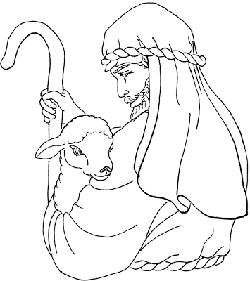
These are the shepherds on, two, three (raise fingers as you count)
They ran to Bethlehem so they could see (run fingers up one arm)
Little Jesus in a stable (put fingers together to make a roof)
They will help to rock his cradle(rock ams)

